Chapter 3: Computational Methodology

Table of Contents

3.1 Abstract 3

3.2 Introduction 4

3.3 Protein Design Algorithm 6

3.3.1 Analysis of membrane protein PDBs 6

3.3.2 Choosing amino acids for membrane protein design 9

3.3.3 Defining the Interface 10

3.3.4 Developing the energy terms 11

3.3.5 Sequence Search 14

3.3.6 Backbone Refinement 15

3.3.7 Mutating the interface 16

3.4 Analysis 18

3.4.1 Software 18

3.4.2 Design Analysis 18

3.4.3 Fluorescence Reconstruction 19

3.4.4 TOXGREEN Conversion 20

3.4.5 Determining proper membrane insertion 22

3.4.6 Identifying proteins associating by designed interface 22

3.4.7 Comparison to energetics 23

3.4.8 Hydrogen bond mutations 23

3.5 Supplementary Info 25

S4 29

3.7 References 34

3.1 Abstract

Recent advances in experimentation allow researchers to collect data in high-throughput. In conjunction with high-throughput data, computational tools and software invented to complement data collection. However, understanding how to use and interpret these computational tools is a necessary skill to properly interpret and analyze high-throughput data. An important approach to designing and distributing computational tools and algorithms is to effectively share them with the research community (Greener et al., 2022; Mougeot et al., 2022; Na, 2020; van Iterson et al., 2012). **The ability to assess protein structures allows researchers to determine how and why proteins fold with unique features essential for function. Computational algorithms have been developed as tools to predict and design unknown proteins using information extracted from solved structures.**

3.2 Introduction

To study MP folding, researchers aim to identify common structural patterns found among MP systems. The protein data bank (PDB) was established to collaborate and share discovered protein structures globally. This tool lets researchers deposit solved protein structures for others to access and evaluate their findings (Berman et al., 2000). Initially, protein structures were solved primarily using x-ray crystallography, which has contributed to solving ~80% of MP structures (Kermani, 2021). MP structures have also been solved by nuclear magnetic resonance (NMR). Solid-state NMR has bypassed the need for detergents in crystallography, obtaining structures of MPs less than 50 residues within lipid bilayers or nanodiscs (Liang & Tamm, 2016). More recently cryo-EM has been used to solve MP structures. In addition to bilayers and nanodiscs, it is possible to solubilize and obtain the structures of MPs within detergents, saposin-lipoprotein nanoparticles, amphipols, and peptidiscs (Januliene & Moeller, 2021). Cryo-EM enables MP structures to be studied in a large variety of different environments, giving researchers the ability to study alternative structures of MPs by changing solubilization conditions.

Despite advancements in MP structural characterization, many efforts take years to ascertain conditions that successfully solve structures in high resolution. MPs make up ~30% of known protein coding genes and integral MPs make up 60% of all drug targets (Arinaminpathy et al., 2009; Overington et al., 2006). Yet only 4.6% of structures deposited in the PDB are MPs (April 2024; PDB). Solving the structures of MPs is difficult due to the need to mimic interactions found between the lipid bilayer and protein. Additionally, MPs are difficult to express in quantities necessary for structural experiments. Instead of focusing on structural determination, some groups aim to utilize information from known structures to advance MP research. Using previously solved protein structures as datasets, researchers have developed computational algorithms and tools that identify common motifs and patterns among MP structures. These tools utilize our current understanding of structures to deduce the impact of forces such as van der Waals packing or hydrogen bonding.

Computational tools have been developed to help assess our understanding of the forces that drive MP association. By deriving the contributions of these forces to protein stability, we can predict and/or design unknown proteins. Molecular dynamics simulations permit researchers to use established statistical and energetic potentials to simulate MP folding over time (Karplus & Petsko, 1990; MacKerell et al., 1998). Structure prediction tools use known information from previously solved structures to estimate the structure of MP folded states (Elofsson & von Heijne, 2007). Protein design strategies build on structure prediction, building unknown structures as simple model systems to assess the current understanding of MP folding (Ghirlanda, 2009). MP design to study TMH systems has been successful: peptides were engineered to associate with the TM helix of integrins and a cytokine receptor (Mravic et al., 2024; Shandler et al., 2011; Yin et al., 2007), an integral MP successfully transferred electrons across the lipid bilayer (Korendovych et al., 2010), a 4-helix bundle was designed to transport Zn2+ across the bilayer (Joh et al., 2014), and phospholamban was redesigned using packing interactions and shown to successfully fold (Mravic et al., 2019).

My research expands on previous prediction and design studies. I surveyed possible TMH dimer conformations by extracting backbone helix-helix conformations from MPs found in the PDB. I then sampled different AA combinations, designing the interface along a standardized backbone sequence. These designed proteins were predicted for their ability to associate using previously established energetic functions, and their stability was assessed using a complementary high-throughput assay. This combination of techniques allowed me to develop an algorithm to design thousands of TMHs to study in high-throughput. In this chapter, I detail the development of my computational algorithm and tools used to analyze my high-throughput data.

3.3 Protein Design Algorithm

To investigate the impact of van der Waals packing on membrane protein association, I opted for a high-throughput design approach. I created a sequence search algorithm that can design thousands of homodimer MP structures using MSL v. 1.1, an open source C++ library that is freely available at http://msl-libraries.org (Kulp et al., 2012). I coupled this algorithm with a structural backbone refinement program also built in MSL. Below, I detail the algorithm alongside experiments and tests that aided in its development.

3.3.1 Analysis of membrane protein PDBs

**Figure 3.1 MP helix-helix density distribution. A)** The geometric terms for homodimer proteins: Distance (x-shift, d), crossing angle (θ), axial rotation (ω), vertical shift (z-shift, Z). **B)** Helix-helix interactions extracted from the PDB in September 2019. Plotted against the angle and distance of each interaction, and density map defined using kernel density estimation.

To computationally design homodimers, I first extracted backbone geometries from all unique MPs found in the Orientations of Membrane Proteins (OPM) database (Lomize et al., 2006). To ensure that I don’t extract redundant helical pairs, the MP structures from OPM were trimmed by sequence similarity. Only unique structures with less than 30% sequence similarity were analyzed (Steinegger & Söding, 2017). We then developed a program in MSL that reads in a structure and identifies helical segments. This program extracts helical segments found within the membrane by measuring the Phi-Psi angles of quadruplets of Cα carbons. Any helical segments composed of at least 13 AAs in length are extracted as individual helices, and the distance is measured between Cα carbons on each unique helical pair. Any two helices with at least 3 Cα carbons within 9Å of each other are extracted as an individual helical pair. I then extracted two parameters, the distance (x-shift, **d**) and the angle (crossing angle, **θ**) (Figure 3.1A), which were plotted as a scatterplot and analyzed using kernel density estimation (Figure 3.1B).

The density plot identifies the most common interaction motifs for dimeric proteins. We expect regions of high density to correlate with designability: By applying my design algorithm to the geometries most often found in nature, they are more likely to successfully interact. First, it’s important to define how these helical geometries are commonly referred to in scientific literature. When viewing dimers from the perspective on the right side of Figure 3.1A, the helix closer to the eye can denote a naming characteristic. In this image, the helix in front is pointing up and to the right. We refer to these dimers with a negative crossing angle as right-handed. The opposite is true for positive crossing angles, where the helix in front is pointing up and to the left. We refer to these dimers as left-handed.

There are three high density regions present in the membrane protein helix-helix dataset. The first design region is present in the left-handed region. Helical pairs interact frequently in the range between 8.5 to 10 Å of interhelical distance and 20 to 40° of crossing angle. Because there is only a single patch of high density, we refer to this region as the left-handed design region (Left). The other two high density regions are found in the right-handed region. Helical pairs are found at a much broader range of distances from 6.5 to over 10 Å of interhelical distance. The region with the most density is found between 7.75 to 9.5 Å interhelical distance and -30 to -60° crossing angle. We refer to this as the right-handed design region (Right). Finally, the third region corresponds to a known dimerization motif called GASright, which is characterized by short interhelical distance (6.5-7.5 Å) and crossing angles of -25 to -55°. The GASright ­is a well characterized and known to be stabilized by a combination of van der Waals packing and the formation of interhelical weak hydrogen bonds between helices (Anderson et al., 2017; Mueller et al., 2014). I decided to design this region as a control, allowing me to compare the stability between proteins A black and white grid
stabilized solely by van der Waals packing and GASright.

**Figure 3.2 Template Geometry Grid.** To determine the axial rotations and z-shifts that would be favorable for protein design, I created a grid of randomized geometries that were assessed for possible clashes at the dimer interface.

To design homodimer proteins, there are two additional geometric features: the rotation of the helix (axial rotation, **ω**) and the vertical shift in the membrane (z-shift, **Z**) (Figure 3.1A). To determine these features for the corresponding angles and distances, I created a grid of template geometries for each design region (Figure 3.2). I used MSL to place poly-Ala sequences at each geometry and assessed for clashing at the interface by measuring the van der Waals energy. If the structure is clashing with the small AA Ala at the interface, then the structure is less likely to be designable as it would not be able to accommodate larger AAs. Any structures that corresponded to an energy less than 100 were saved, allowing some leeway for potential clashes in each design region that could be mitigated with backbone refinement. I plotted the saved geometries on density maps and extracted the ranges of axial rotations and z-shifts **(S1, S2, and S3)**. Finally, I generated 1000s of geometries for each design region, where the angle and distance are chosen from the membrane protein density map, and the rotation and z-shift are chosen from the identified ranges where clashing did not occur in poly-Ala sequences. These geometries were used as input backbone templates for protein design.

3.3.2 Choosing amino acids for membrane protein design

**Figure 3.3 Membrane Protein AA Percent Composition. A)** Percent composition of TM-helical regions for all sequences and consensus sequences (Liu et al., 2002). **B)** Adjusted percent AA composition of AAs chosen for design from nonredundant TM-helical pair sequences.

Liu et al. 2002 identified the percent composition of AAs as found in all TM-helical regions in membrane protein sequences (Figure 3.3A). Inspired by the previous literature, I determined the composition of AAs found in my nonredundant extracted helical pair dataset. Since I aim to study the effect of sidechain packing on association, I chose only to design with a subset of AAs to decrease the potential for association by alternate forces at the interface. To prevent the formation of disulfide bridges, the two sulfur containing AAs (Cys and Met) were removed (**cite**). AAs with the potential to form charged interactions (Lys and Arg) were also excluded (**cite**). Histidine, often forming cation-π interactions, was excluded. AAs that often form hydrogen bonds (Asp, Glu, Asn, Gln) were removed, with the exclusion of Ser, Tyr, and Thr due to how frequently we found them in our TM helical pairs. Finally, Pro, which is known to form kinks in helices, was excluded from the design pool. This left me with 10 AAs to use for protein design (Figure 3.3B). Each of these AAs was allowed to be designed along the interface during the sequence search described in section 3.3.5.

3.3.3 Defining the Interface

**Figure 3.4 Solvent Accessible Surface Area (SASA).** Side view and top-down view of helical dimers. SASA is determined by the amount of area on both helices that is not in contact. Can be thought of similarly to rolling a ball along the surface of the protein structure: The ball can only access parts of the protein not in contact, or outside of the X (the most buried region of the dimer interface).

To reduce heterogeneity in protein expression, I designed the interface of a standardized TM helix of 21 AAs consisting of a poly-Leu backbone, a strategy previously applied to study the association of GASright proteins (Anderson et al., 2017). In my first protein design run, I used Solvent Accessible Surface Area (SASA) to identify the interfacial positions of a protein set at a geometry from my membrane protein analysis (Figure 3.4). The SASA was calculated for each position on the dimer and the interface defined as the 8 positions with the least amount of access to the solvent, or the most buried positions. Although we were successfully able to design sequences that associate, our energy score showed little correlation to association. However, we found that sequences with similar interfaces had better correlation with our A video game screen with a black background
energy score (**S4**).

**Figure 3.5 Protein design interfaces.** Sequence design was performed along a poly-Leucine backbone sequence with defined interfaces for each design region. Interface designated by positions with X.

For subsequent design runs, I standardized the interface for each region (Figure 3.5). The GASright was previously studied using similarly standardized backbones, so I chose to apply the same 8 positions as the interface. Since Right designs have similar geometric parameters outside of a larger x-shift, I used the same 8 interfacial positions as GASright. For the Left designs, I visually inspected a variety of backbone templates with unique axial rotations and zShifts and defined 3 interfaces. These interfaces accounted for known left-handed association motifs including the leucine zipper, knobs-into-holes, and coiled coils (Ash et al., 2004; Bornberg-Bauer et al., 1998; Walshaw & Woolfson, 2003). Standardizing the interfaces permitted me to come up with a consistent mutational strategy to assess my proteins for their association at the given interface that is described in section 3.3.6.

3.3.4 Developing the energy terms

To predict the stability of my designed proteins, I applied the same set of energy terms used previously by CATM: CHARMM_VDW for van der Waals packing, SCWRL4_HBOND for hydrogen bonding, and CHARMM_IMM1 to estimate the interactions found in the membrane environment (Anderson et al., 2017). These terms are computed for each protein during the sequence search to find the best interfacial sequence for the input geometric structure. To determine the stability of my designed dimers, I computed the interaction energies of the dimer structure and two monomers, and then subtracted the monomer energy from the dimer energy:

However, computing the monomer energy for each sequence during the sequence search is time consuming, resulting in a bottleneck in the algorithm and limiting the number of sequences I could design. To account for this, I developed an energy term that estimates the monomer energy of each sequence.

**Figure 3.6 Developing the BASELINE_MONOMER term.** A baseline energy term was developed to increase computational speed, estimating the stability of the sequence as a monomer. A strong correlation was found between the calculated Monomer energy (x-axis) and the BASELINE_MONOMER (y-axis).

The BASELINE_MONOMER term was created by measuring the energy of the previously mentioned terms for each individual amino acid on a monomeric helix. I computed the energetics of 10000 random sequences and measured the self and pair energies for each amino acid. The self-energy represents the energy contribution for an individual amino acid to the protein stability alone, while the pair energies represent the energy contribution between any two interacting amino acids (**cite**). I measured the pair energies for all AA pairs on the sequence and found that there was no longer a pair interaction between amino acids more than 10 away from each other. From each iteration, I calculated the average of all self and pair energies and saw a strong correlation between the measured monomer energy and the BASELINE_MONOMER term (Figure 3.6). This BASELINE_MONOMER term was made for only the subset of amino acids used in design (Figure 3.3B) and would need to be rerun to establish the term for any additional amino acids. This term was helpful in decreasing computational time, enabling us to design 1000s of sequences within a week.

Another issue that I encountered was that many of my initial designs were often composed of only 2-3 different AAs. This result could impact our protein expression and insertion, as natural membrane protein sequences are often made of a diverse set of AAs. To account for this sequence diversity, I developed a SEQUENCE_ENTROPY term that outputs an energy based on how similar a sequence is to the composition of a natural membrane protein sequence (Figure 3.3). To convert the composition of AAs in a membrane sequence to an energy term, I utilized the following equation based on the Boltzmann entropy formula:

$$SEQUENCE_ENTROPY=-log(probability)×RT$$

where R is the gas constant and T is temperature defaulted to 298K (RT = 0.592). To compute the sequence entropy, I needed to calculate the probability tht the sequence occurs in membrane. First, the number of each AA (#AA) is counted within the sequence. Using these values, I then calculated the number of possible permutations for the sequence. This is determined using the following equation:

$$permutations={n!}/{(\#AA1! × \#AA2! × … )}$$

where n is the number of positions, which is divided by the factorial for #AA in the sequence multiplied, or the total number of combinations possible. The probability is computed using the frequency of each AA in membrane protein sequences (freq_AA) to the power of the number of each AA in the sequence multiplied by the permutations:

$$probability=({freq_AA1}^{\#AA1} × {freq_AA2}^{\#AA2}× …)× permutations$$

This probability is inserted into the sequence entropy equation, returning a value that can be applied as an energy term for each sequence. My algorithm utilizes this term as an additional energy, predicting the stability of my designed homodimer sequences and adjusting the energy by the likelihood that they are found in natural membrane proteins sequences.

3.3.5 Sequence Search

**Figure 3.7 Sequence Search Example.** A random position on the input sequence (red) is selected and switched to another AA. The energy is then calculated for the new sequence and compared to the energy of the previous sequence. Sequences with more stable energies (more negative) are always accepted.

For each input geometry, the algorithm first defines the best sequence using the Self Consistent Mean Field (SCMF) theory as implemented in MSL. This method estimates the conformational entropy of each design AA as a probability that it is present within the dimer interface (Koehl & Delarue, 1994). The sequence from the SCMF is then run through a MC sequence optimization: A random position on the interface is switched to a random AA, and the energy is calculated using the combination of the CATM energy terms and the developed energy terms defined in section 3.4.3.

Each energy term can be multiplied by an optional weight, meaning the total energy can be changed proportionately by the given weights. Previous research in our lab defaulted the weights of the CATM energy terms to 1, which was repeated in this study. To determine if SEQUENCE_ENTROPY performed better at different weights, I ran a test using weights of 1, 5, 10, 50, and 100 and calculated the AA composition in these designs. Weights greater than 10 were found to be optimal for mimicking the AA composition found in TM helical pairs. I chose to use 10 as it resulted in the SEQUENCE_ENTROPY term affecting the total energy at the same order of magnitude as the other terms. The equation for the total energy is as follows:

$$Energy=Dimer -(2×BASELINE_MONOMER) -(SEQUENCE_ENTROPY×Weight)$$

The total energy is used for the acceptance criteria, and the MC searches for a multitude of sequences before reaching an energetic minimum. The sequences accepted during the search are saved into an output trajectory file alongside the energy. The sequence with the best total energy is saved, and that single design undergoes backbone refinement.

3.3.6 Backbone Refinement

After initially starting with a specific backbone template, the newly designed sequence undergoes an MC based structural refinement procedure. The structure undergoes MC backbone perturbations, where one of the four inter-helical parameters (Figure 3.1A: x-shift, crossing angle, axial rotation, z-shift) is chosen and shifted during each cycle. The total energy for the refined structure is used as the acceptance criteria, with the BASELINE_MONOMER energy being replaced by the computed monomer energy and the SEQUENCE_ENTROPY term no longer applied:

$$Total Energy=Dimer - Monomer$$

The backbone refined geometry can be input into the sequence search to find other designable sequences. The sequence, energetics, geometries, and their corresponding structures are output to a folder for analysis (Table **S?**). After initially only refining my backbone in my design script, I developed another program in MSL that runs a more thorough refinement protocol. I found that this program improves the structure and energetics described in section 3.3.6. This updated algorithm was used for determining energies for all sequences and is detailed in supplementary figure **S?** and Table **S?**.

3.4 Analysis

3.4.1 Software

The following calculations, analyses, and graphing were implemented and performed using Python v. 2.7. Relevant packages include:

Pandas: (McKinney, 2011)

DNAChisel: (Zulkower & Rosser, 2020)

Numpy: (McKinney, 2012)

Matplotlib: (Tosi, 2009)

Seaborn: (Waskom, 2021)

Scipy: (Virtanen et al., 2020)

Sklearn: (Pedregosa et al., 2011)

Pymol: (DeLano, 2002)

All programs and code can be found on Github at …

3.4.2 Design Analysis and Choosing Interface Mutations

To analyze my designs, I wrote a script that compiles all design directories and outputs a variety of plots and csv files **(S? and Table S?)**. To ensure that we have a spread of energy scores for our design pool, a subset of sequences was selected from all designs (**S?**). Because it is not feasible to solve the structures of all designed sequences, I decided on a mutational approach to confirm that my designs dimerize at the designed interface. Mutations expected to decrease association were chosen by two additional programs developed in MSL.

**Figure 3.8 Clash and Void mutations.** Mutations to Ile (top) results in interfacial positions on one helix overlapping with atoms on the opposite helix. Mutations to Ala (bottom) results in holes at the interface. Each of these mutations was expected to decrease association.

The first program identifies clash mutants, where an interfacial position was mutated to an Ile which can protrude into the opposing helix, often disrupting the ability for a protein to associate (Table **S?**). The second program identifies void mutants, where an interfacial position was mutated to a smaller Ala, aiming to decrease the amount of packing at the interface (Table **S?**). The designed protein structure is read into each program as an input, and the interface mutated one at a time to either Ile (clash) or Ala (void). Each program outputs either an energy score (clash) or SASA (void) for the mutant sequence. The two clashing mutations with the highest energy (least stable) and the two void mutants with the largest increase in SASA (less packed) were chosen for experiments. We expect these mutants to enable us to determine if our proteins associate by the designed interface (Figure 3.8). The designed sequences, their respective mutants, and a variety of control sequences were ordered in an oligo pool library from Twist Bioscience and cloned into plasmids for TOXGREEN sort-seq (**S?**).

3.4.3 Fluorescence Reconstruction

As detailed previously in **cite sort-seq paper**, a library of genes coding for designed TMs is cloned into the ToxR plasmid, allowing each design to be expressed in *E. coli*. These plasmids are used to assess dimerization by TOXGREEN, which is detailed in **SECTION**. Each cell outputs fluorescence corresponding to the dimerization propensity of the expressed sequence. A population of *E. coli* containing the library of sequences is sorted into separate bins through fluorescence activated cell sorting (**S?**). Plasmids obtained from the sorted populations of *E. coli* are sent for Next Generation Sequencing (NGS). The sequencing returns counts for each sequence found in each bin, which are used to reconstruct the fluorescence profile for each sequence. This reconstructed fluorescence is used to assess the dimerization propensity of all sequences in the population. Reconstructed fluorescence levels were calculated as a weighted average (Kosuri et al., 2013). This method normalizes the reads per protein per bin with the fraction of the population found in that bin. The normalized fractional contribution of each bin (j) for each protein (i), aij is calculated as:

where the normalized fractional contribution is then multiplied by the median fluorescence of that bin (mj­). Finally, the contributions for each sorted bin are summed to determine the reconstructed fluorescence. The sequencing data is run through a Python pipeline that computes the above reconstructed fluorescence for all sequences found in the NGS data. The reconstruction resulted in 949 of our 1045 designs (91%) present within each replicate of the NGS data.

3.4.4 TOXGREEN Conversion

Studies using TOXCAT systems typically normalize the dimerization propensity by comparing dimerization propensity to the well-studied strong dimer Glycophorin A (GpA), which is included as a control in each of our libraries. This normalization is calculated as a percentage of GpA fluorescence (%GpA). The reconstructed fluorescence is converted to %GpA using the following equation:

$$\%GpA={Design Fluorescence}/{GpA Fluorescence}×100\%$$

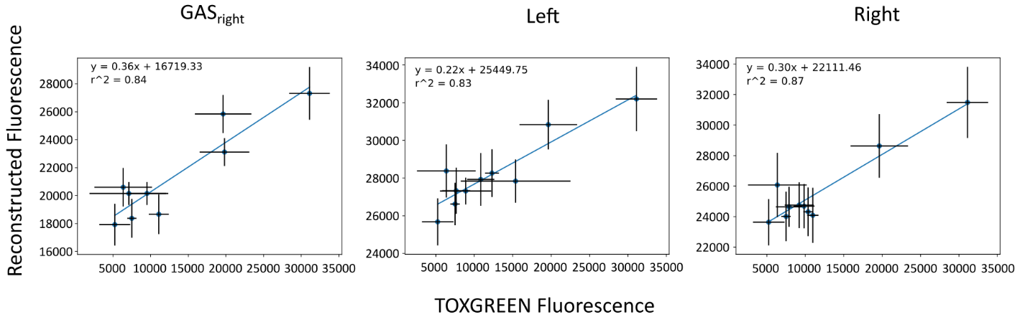To calibrate our fluorescence properly to %GpA, we also include a variety of control sequences that we have previously studied using TOXGREEN. Upon initial inspection, the controls present in our experiment were reconstructed to a lower %GpA value than we’ve previously found in TOXGREEN.

**Figure 3.10 TOXGREEN Converted Fluorescence.** Fluorescence from reconstruction is converted to TOXGREEN fluorescence using correlation plots between a set of controls and subset of designs previously tested in TOXGREEN**.**

I conducted a separate low-throughput TOXGREEN experiment on the control sequences and a subset of my designed sequences. When I compared the TOXGREEN to the reconstructed data, the reconstructed values were noticeably smaller for most sequences. However, when we plotted TOXGREEN versus the reconstruction, we found a clear correlation between the two datasets (Figure 3.10). To calibrate our reconstruction to TOXGREEN, we converted the values from the reconstruction data to TOXGREEN fluorescence. We applied the equation found by the correlation between reconstructed fluorescence and TOXGREEN fluorescence. The reconstructed fluorescence is multiplied by the slope and then subtracted by the y-intercept of the correlation. The values for each sequence are averaged with their corresponding replicates and normalized to the GpA sorted in each design population. This conversion let us differentiate between different levels of dimerization propensity as seen previously in TOXGREEN experiments: monomers (0-35%), weak dimers (35-60%), and strong dimers (>60%).

3.4.5 Determining proper membrane insertion

A liquid maltose growth assay was run in triplicate as in **cite sort-seq**. Briefly, cultures composed of *E. coli* containing plasmids for the designs, mutants, and controls are grown overnight. These are normalized by OD600 in the morning and the normalized population added to flasks of liquid maltose media and grown for 36H, with timepoints taken every 6 hours. The populations for each timepoint are spun down, plasmids extracted through miniprep, and prepared for NGS. Within each population are control sequences that are known not to insert in the membrane, as shown by failure to grow on maltose plates. To assess whether the sequences properly insert into the membrane, we compare the relative abundance of our designs to these controls. The relative abundance from the overnight growth (0H) and the growth in liquid maltose at 30H to determine the ability to insert:

$$Relative Abundance={NGS Count 0H}/{NGS Count 30H}$$

Sequences that are more abundant than these controls are considered properly inserted. 708 of the 949 designs present (75%) pass our insertion test.

3.4.6 Identifying proteins associating by designed interface

**Figure 3.11 Reconstructed Fluorescence of Designs versus Mutants.** Fluorescence of Designs (green), clash (red), and void/Large->Ala (yellow) mutants. Significance for designs versus each mutant group is calculated and displayed above each group.

To determine if sequences dimerize along the designed interface, we sought to identify sequences where the mutant results in a significant decrease in association. We analyzed the fluorescence for the clash and void mutants against the fluorescence of our designed sequences (Figure 3.11). When comparing the clash mutations to the fluorescence of the design, we saw a significant decrease in their association (p<0.05). However, the void mutants did not show this same decrease, often resulting in similar fluorescence as the WT designs. This data suggests that mutating larger amino acids to the smaller Ala for loss of packing does not significantly impact association. It is possible that these mutants dimerize by an alternate interface than our designed structures. We decided to move forward by trimming our data using the clashing mutants, which appear to disrupt association by our designed interface. We trimmed our data for any designs where the clashing mutation was monomeric (< 35% GpA). This resulted in 379 out of the 708 designs that pass the maltose test (54%) associate by our designed interface.

3.4.7 Comparison to energetics

**Figure 3.12 Energy vs Reconstructed TOXGREEN.** Dimerization propensity in terms of %GpA against the predicted energy score. Glycophorin A and it’s monomerizing mutant (Glycophorin A*) are represented as dashed lines at 100% and 18% GpA, respective. The cutoff for monomer mutants is represented as a solid red line at 35% GpA.

We plotted the energy score against the dimerization propensity in terms of %GpA for each protein and separated the data by design region. Spearman ranked correlation between the energy score and the dimerization propensity were calculated. The energy score does not correlate well to proteins outside of the GASright region (Figure 3.12). This data suggests that although we were able to design sequences that associate (>35% GpA), we are unable to predict the dimerization propensity of proteins associated solely by van der Waals packing using our energetics. However, many of our designs outside of the GASright associate as weak dimers (35-60% GpA). This suggests that our energetics may not be well tuned to predict weakly dimerizing proteins. I discuss how this can be addressed in future experiments in Chapter 4.

3.4.8 Hydrogen bond mutations

In our design procedure, we included AAs that had the potential to hydrogen bond due to how frequently they are found in membrane proteins. Our design energies predicted low levels of hydrogen bonding, suggesting that they wouldn’t impact association. However, because our energetics show little correlation with experimental dimerization propensity, we are unable to confidently state that our sequences associate solely by van der Waals packing without the influence of other forces like hydrogen bonding.

To ascertain if our proteins associate solely by packing, I conducted an experiment where we mutated our proteins to remove the potential for hydrogen bonding. To identify proteins with the potential for hydrogen bonding, I wrote a Python script that searches through my protein structures and identifies any oxygen atoms within 3Å, a generous threshold for potential hydrogen bond formation. I identified 17 proteins that associated from mildly weak to strong dimers (>40% GpA) with the potential for at least 1 hydrogen bond. I mutated all hydrogen bonding AAs in these sequences to hydrophobic AAs with similar steric bulk: Thr->Val, Tyr->Phe, and Ser->Ala. I ordered the original design sequences, their respective clash mutants, and the hydrophobic mutants as gblocks from Twist Bioscience and successfully cloned 13/17 proteins into the TOXGREEN plasmid for experiments.

**Figure 3.13 TOXGREEN on hydrogen bonding AAs.** TOXGREEN fluorescence of 6 biological replicates for each design (WT), clash (C), and hydrophobic (HP) mutations.

8/13 designs were found to properly associate according to our designed interface, where either the clash (C) or hydrophobic (HP) mutations resulted in a noticeable decrease in association when compared to the WT (Figure 3.13). 4/8 of the hydrophobic mutations displayed similar or increased association when as compared to WT. Although we are unable to predict association using our energy terms, we have successfully designed proteins that associate without hydrogen bonding. This data suggests that van der Waals packing is driving the association of a variety of our designed membrane proteins.

3.5 Summary

In this section, I detailed the computational methods I used in my research. Because I did not produce a web-based design script, describing these methods is necessary for reproducibility and understanding for future researchers. The methods described include: protein design algorithm, backbone repack scripts, mutation programs built using MSL. I also describe analysis scripts built in python. The outputs for each of these programs are referenced in the supplementary figures and tables. Finally, I reference the results from my paper that can be improved upon in future experiments. Ways to further improve my design algorithm, the correlation to energy terms, and to study the impact of other forces on membrane protein folding is further described in Chapter 4: Future Directions.

3.6 Supplementary Info

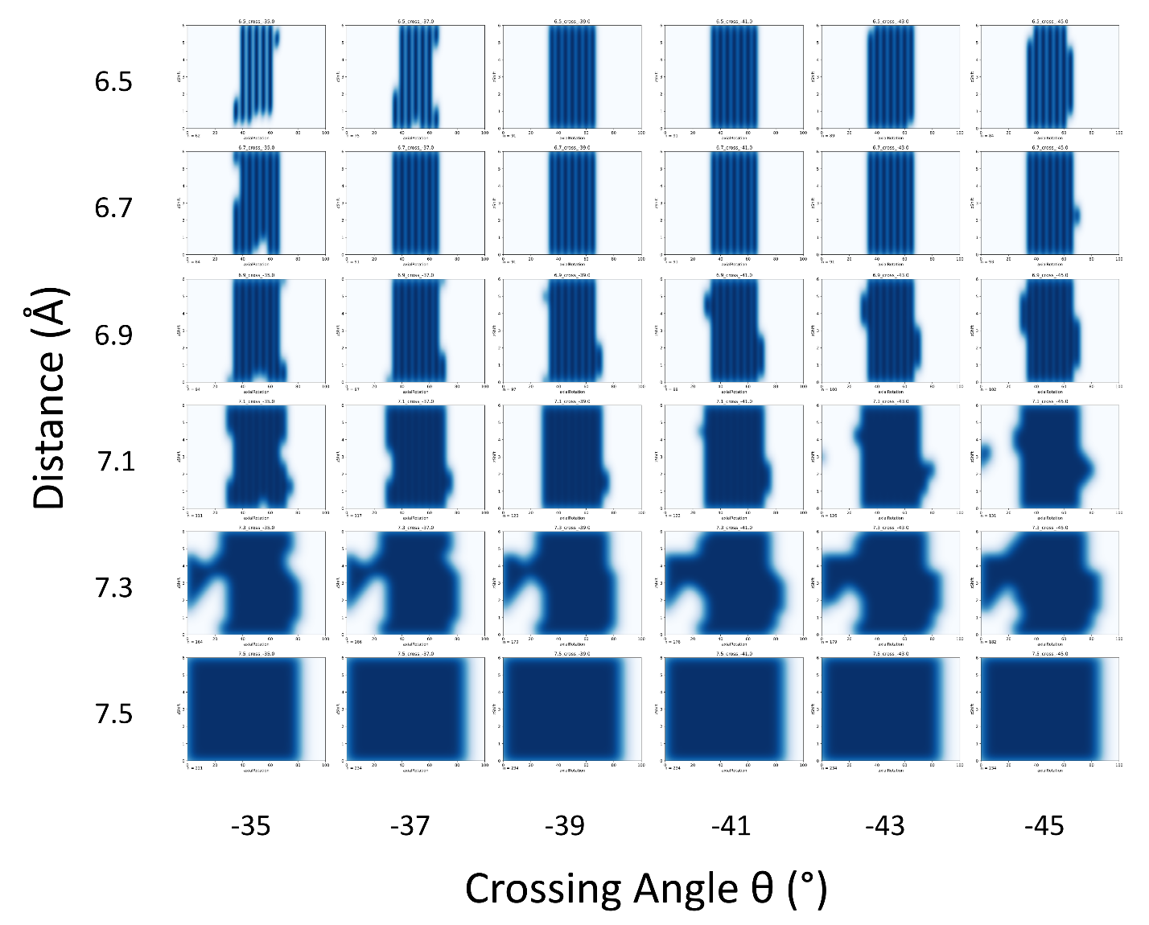**S1 GASright z-shift vs axial rotation grid**

**S2 Left z-shift vs axial rotation grid**

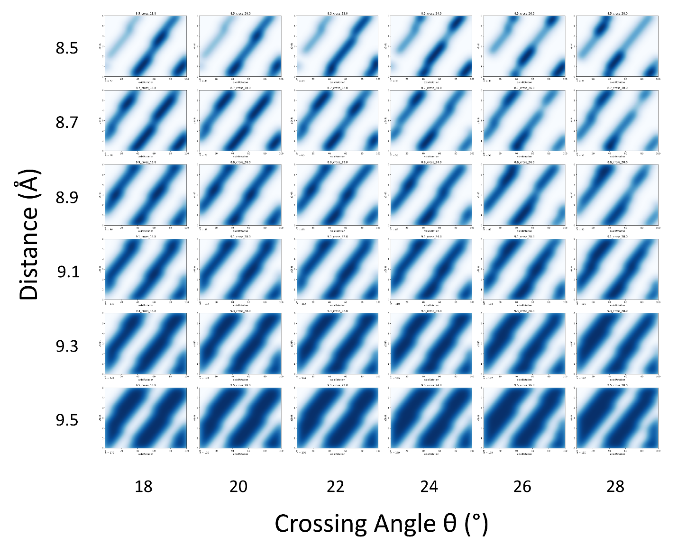

**S3 Right z-shift vs axial rotation grid**

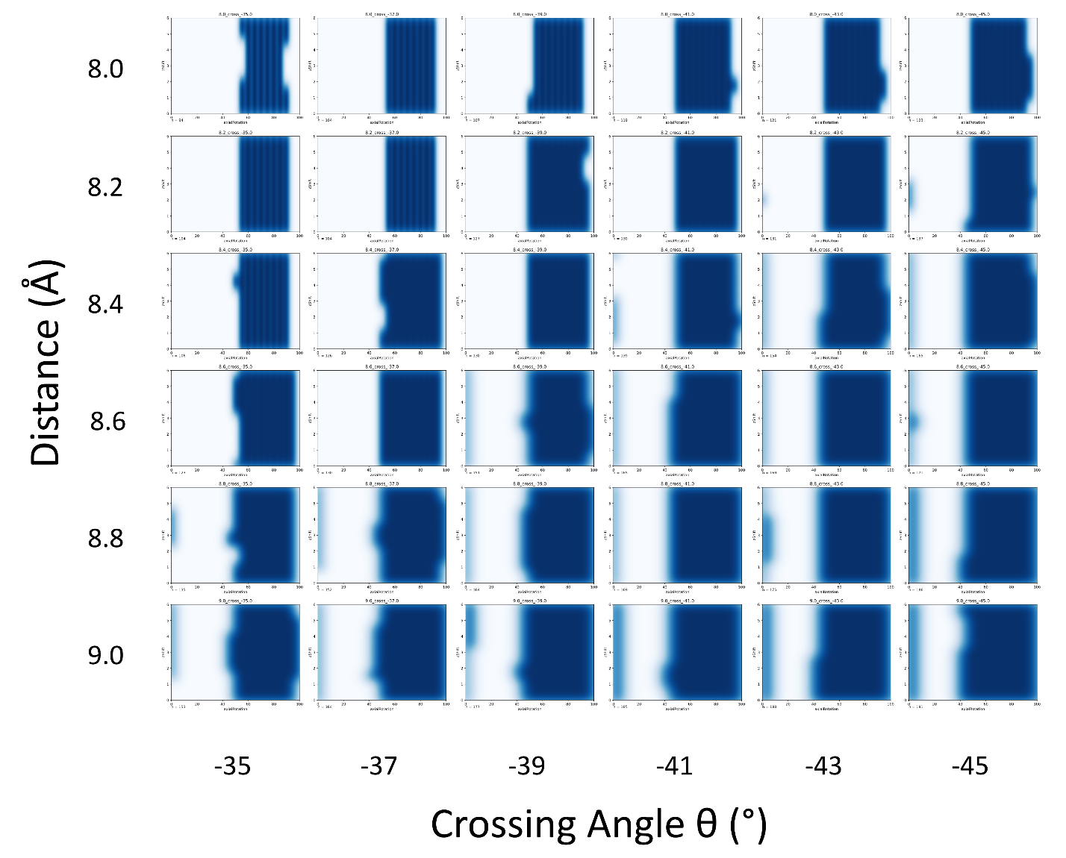

**S5**

**S4**

S7

**Figure S7 Updated backbone refinement comparison.** Energies from previous backbone refinement (y-axis) versus the improved version (x-axis). Line to delineate x=y. Most of the points are found to the left of the line, showing that the improved version of the refinement results in more stable energies. Structures are also shown to be more well-packed than previous (**add here**)

The program reads an input structure and sequence. To ensure that the mutated sequence can find alternate dimer interfaces, the structure undergoes a more detailed MC backbone refinement. In the original backbone refinement, each geometric shift randomly alters the structure by choosing a value between 0 and an input upper limit. For example: When the geometric x-shift is chosen, a random value from 0-0.5 Å is applied to the structure. In this version, the geometric term procedurally decreases to a lower limit, such as 0.1 Å. Each cycle, the chosen geometric term is decreased by multiplying it by the metropolis criteria until it reaches the lower limit. Once the lower limit is reached, this value is always used when this term is shifted again. After initially testing this process on my designs, I found that the new backbone refinement resulted in more stable energies for my designed proteins (Figure 3.5). The energetics from this refinement is utilized to evaluate my structures and mutants against their reconstructed fluorescence in sort-seq.

**S**

**Figure S? Sort-Seq.** A library of genes coding for my designed sequences is cloned into the ToxR plasmid and cloned into *E. coli* cells. The fluorescence from each cell is assessed through fluorescence activated cell sorting. Sorted populations are then sent for deep sequencing, where we get counts for each of the sequences found in each bin. These counts are used to reconstruct the fluorescence profile for each sequence, allowing us to determine the dimerization propensity for every sequence in the population.

S8 Figure for ala vs leucine termini

During my design run, I encountered an issue upon visual inspection of my poly-Leucine standardized sequence PDBs: interfaces often included voids to accommodate Leucine at the termini, preventing clashing interactions (**figure**). Although these designs had a considerable amount of van der Waals packing according to our energetics, we wanted to ensure that the interface was driving association. I chose to repeat my design process with the smaller AA Alanine at the termini. These structures were found to include less voids and a well packed interface (**figure?**). Although the termini are unchanged in our experiment, we included these Alanine termini designs in our dataset with the assumption that helices in the experiment would be more flexible to accommodate these interfaces than our rigid helices. **(add to a supplementary figure; just a detail)**

**Figure S3 Design Energy Score Ranges.** Range of energy scores for sequences found in TOXGREEN.

**Supplementary tables for explaining outputs for each script**

**MSL scripts**

**interhelicalCoordinates.cpp**

|  |  |
| --- | --- |
| **Output File** | **Description** |
| fit_#-#.pdb |  |
| helix_#.pdb | Structure of identified helices |
| pair_#-#.pdb | Structure of each pair, included with centroids identifying the point of closest approach between the helices |
| pairGeometryReport.csv | Geometric information extracted from each pair, including sequence, helical stretches, and points of closest approach |
| pairReport.csv | Geometric information extracted from each pair |
| proteinReport.csv | Information extracted from each protein structure, including identifying phi and psi angles, potential for hydrogen bonding, and helicity of each position |
| rerun_conf.txt | The configuration file that can be used to rerun |
| segmentReport.csv | Information about identified helices with start and end positions and length of each helix |

**seqDesign.cpp**

|  |  |
| --- | --- |
| **Output File** | **Description** |
| #_#.pdb | Structure of the designed interface |
| bbRepack_#.out | Information about the repack for the structure |
| bbRepack_trajectory_#.pdb | Structural trajectory for the backbone repack |
| energyFile.csv | File to be analyzed; contains the energies, geometries, sequence, rotamers, interface, and SASA for each design |
| errors.out | Error output file |
| rerun.config | The configuration file that can be used to rerun |
| seqSearch_#.pdb | Pdb for each design prebackbone repack |
| sequence_search_trajectory_#.pdb | Pdb for the sequences accepted during the search trajectory for each design interface |
| sequenceSearchEnergyLandscape_#.out | Energy landscape trajectory for each design |
| summary.out | Summary output file for the run, includes the elapsed time of the program through each step of design |
| x#_cross#_ax#_z#_vdW#.pdb | Pdb for the input design geometry, with the vdW energy output from the clashing check |

**bbRepack.cpp**

|  |  |
| --- | --- |
| **Output File** | **Description** |
| #.pdb | Repacked structure |
| #_repack.out | Output file for each structure repack, with the time elapsed and the before and after repack energies |
| summary.out | Summary file including the elapsed time for each step of the repack |
| energyFile.csv | File to be analyzed; contains the energies, geometries, sequence, rotamers, interface, and SASA for each design |
| errors.out | Error output file |
| initialPdb.pdb | Pdb for the input sequence set at the geometry of the input pdb |
| monomer.pdb | Monomer pdb structure |
| rerun.config | The configuration file that can be used to rerun |
| startPdb.pdb | Copied structure of the input pdb |

**getClashMutants.cpp (formerly calcMutantEnergy.cpp)**

|  |  |
| --- | --- |
| **Output File** | **Description** |
|  |  |
|  |  |
|  |  |
|  |  |
|  |  |
|  |  |
|  |  |
|  |  |
|  |  |

**getVoidMutants.cpp (formerly findPdbSASAVoids.cpp)**

|  |  |
| --- | --- |
| **Output File** | **Description** |
|  |  |
|  |  |
|  |  |
|  |  |
|  |  |
|  |  |
|  |  |
|  |  |
|  |  |

**Python Scripts**

**Design Analysis**

|  |  |
| --- | --- |
| **Script** | **Description** |
| main.py | Driver script that runs the other scripts by reading in the config file |
| compileEnergyFiles.py | Compiles the energy files from output from the sequence design script |
| analyzeDesignData.py | Main analysis script, outputting plots and csv files |
| createPymolSessionFiles.py | Makes pymol session files for the designed sequences with the most stable energies |
| createBackboneRepackFile.py | Creates a csv file for inputting into bbRepack script |

**NGS Reconstruction**

|  |  |
| --- | --- |
| **Script** | **Description** |
| main.py | Driver script that runs the other scripts by reading in the config file; contains helpful functions to for the other scripts |
| fastqToTxt.pl | Converts the fastq NGS data to a txt file that can be analyzed |
| ngsAnalysis.py | Reconstructs the fluorescence from the converted NGS data |

**toxgreenConversion.py**

|  |  |
| --- | --- |
| **Script** | **Description** |
| toxgreenConversion.py | Driver script that runs the other scripts by reading in the config file |
| adjustFluorByControlFlow_percentGpA_stdFix_fluor.py | Script that converts the fluorescence |
| filterWithComputation_percentGpA_stdFix.py | Outputs the design computational data with their sequences and filters the data standard deviation; removes sequences with fluorescence < 0 or where fluorescence – stddev < 0; outputs are used in pdbOptimizationAnalysis |

**pdbOptimizationAnalysis.py**

|  |  |
| --- | --- |
| **Script** | **Description** |
| pdbOptimizationAnalysis.py | Driver script that runs the other scripts by reading in the config file |
| stripSequenceEnds.py | Removes the first 3 letters and last 4 letters of all sequences (also removed in the later parts and reinserted later; to match up ala and leu designs) |
| keepMaltoseData.py | Filters the data for sequences that pass maltose test |
| compileFilesFromDirectories.py | Compiles the energyFile.csv from bbRepack to use in this analysis |
| addPercentGpaToDf.py | Appends the fluorescence and percentGpA data to the energy data |
| keepBestClashing.py | Filters data using the given clashing checks |
| combineFilesAndPlot.py | Combines the clash filtered files and the energy data from the maltose passing data, then plots using analyzeData.py |
| makeKdePlots.py | Outputs the kde plots for each dataset |
| convertToDeltaG.py | Converts the fluorescence data to deltaG |
| graphDeltaG.py | Graphs the deltaG data |
| analyzeData.py | Outputs plots of the energy data against the fluorescence and %GpA |

**sequenceAnalysis.py**

|  |  |
| --- | --- |
| **Script** | **Description** |
| sequenceAnalysis.py | Driver script that runs the other scripts by reading in the config file |
| addNecessaryColumns.py | Using the mutant and sequence files from the clash filtered data in pdbOptimizationAnalysis, adds columns for analysis (WT and mutant AA, position of mutation, Type of sequence WT, Clash, Void) |
| plotBoxplotsPerAAPosition.py | Plots boxplots for differences between AA positions |
| plotBoxplotsCombined.py | Plots boxplots for differences between each design region |
| graphDeltaFluorescence.py | Graphs plots for the change in fluorescence between WT and Mutant sequence |

* hbondAnalysis and structureAnalysis are currently separate…maybe compile those in the runAllAnalysis if I can? I think definitely at least the hbond stuff if that data comes up looking good.

3.7 References

Anderson, S. M., Mueller, B. K., Lange, E. J., & Senes, A. (2017). Combination of Cα-H Hydrogen Bonds and van der Waals Packing Modulates the Stability of GxxxG-Mediated Dimers in Membranes. *J Am Chem Soc*, *139*(44), 15774-15783. <https://doi.org/10.1021/jacs.7b07505>

Arinaminpathy, Y., Khurana, E., Engelman, D. M., & Gerstein, M. B. (2009). Computational analysis of membrane proteins: the largest class of drug targets. *Drug Discovery Today*, *14*(23), 1130-1135. <https://doi.org/https://doi.org/10.1016/j.drudis.2009.08.006>

Ash, W. L., Stockner, T., MacCallum, J. L., & Tieleman, D. P. (2004). Computer modeling of polyleucine-based coiled coil dimers in a realistic membrane environment: insight into helix-helix interactions in membrane proteins. *Biochemistry*, *43*(28), 9050-9060. <https://doi.org/10.1021/bi0494572>

Berman, H. M., Westbrook, J., Feng, Z., Gilliland, G., Bhat, T. N., Weissig, H.,…Bourne, P. E. (2000). The protein data bank. *Nucleic acids research*, *28*(1), 235-242.

Bornberg-Bauer, E., Rivals, E., & Vingron, M. (1998). Computational approaches to identify leucine zippers. *Nucleic Acids Research*, *26*(11), 2740-2746. <https://doi.org/10.1093/nar/26.11.2740>

DeLano, W. L. (2002). Pymol: An open-source molecular graphics tool. *CCP4 Newsl. Protein Crystallogr*, *40*(1), 82-92.

Elofsson, A., & von Heijne, G. (2007). Membrane protein structure: prediction versus reality. *Annu Rev Biochem*, *76*, 125-140. <https://doi.org/10.1146/annurev.biochem.76.052705.163539>

Ghirlanda, G. (2009). Design of membrane proteins: toward functional systems. *Current Opinion in Chemical Biology*, *13*(5), 643-651. <https://doi.org/https://doi.org/10.1016/j.cbpa.2009.09.017>

Greener, J. G., Kandathil, S. M., Moffat, L., & Jones, D. T. (2022). A guide to machine learning for biologists. *Nat Rev Mol Cell Biol*, *23*(1), 40-55. <https://doi.org/10.1038/s41580-021-00407-0>

Januliene, D., & Moeller, A. (2021). Single-Particle Cryo-EM of Membrane Proteins. *Methods Mol Biol*, *2302*, 153-178. <https://doi.org/10.1007/978-1-0716-1394-8_9>

Joh, N. H., Wang, T., Bhate, M. P., Acharya, R., Wu, Y., Grabe, M.,…DeGrado, W. F. (2014). De novo design of a transmembrane Zn²⁺-transporting four-helix bundle. *Science*, *346*(6216), 1520-1524. <https://doi.org/10.1126/science.1261172>

Karplus, M., & Petsko, G. A. (1990). Molecular dynamics simulations in biology. *Nature*, *347*(6294), 631-639. <https://doi.org/10.1038/347631a0>

Kermani, A. A. (2021). A guide to membrane protein X-ray crystallography. *FEBS J*, *288*(20), 5788-5804. <https://doi.org/10.1111/febs.15676>

Koehl, P., & Delarue, M. (1994). Application of a Self-consistent Mean Field Theory to Predict Protein Side-chains Conformation and Estimate Their Conformational Entropy. *239*(2), 249-275.

Korendovych, I. V., Senes, A., Kim, Y. H., Lear, J. D., Fry, H. C., Therien, M. J.,…Degrado, W. F. (2010). De novo design and molecular assembly of a transmembrane diporphyrin-binding protein complex. *J Am Chem Soc*, *132*(44), 15516-15518. <https://doi.org/10.1021/ja107487b>

Kosuri, S., Goodman, D. B., Cambray, G., Mutalik, V. K., Gao, Y., Arkin, A. P.,…Church, G. M. (2013). Composability of regulatory sequences controlling transcription and translation in Escherichia coli. *Proc Natl Acad Sci U S A*, *110*(34), 14024-14029. <https://doi.org/10.1073/pnas.1301301110>

Kulp, D. W., Subramaniam, S., Donald, J. E., Hannigan, B. T., Mueller, B. K., Grigoryan, G., & Senes, A. (2012). Structural informatics, modeling, and design with an open-source Molecular Software Library (MSL). *J Comput Chem*, *33*(20), 1645-1661. <https://doi.org/10.1002/jcc.22968>

Liang, B., & Tamm, L. K. (2016). NMR as a tool to investigate the structure, dynamics and function of membrane proteins. *Nat Struct Mol Biol*, *23*(6), 468-474. <https://doi.org/10.1038/nsmb.3226>

Liu, Y., Engelman, D. M., & Gerstein, M. (2002). Genomic analysis of membrane protein families: abundance and conserved motifs. *Genome Biol*, *3*(10), research0054. <https://doi.org/10.1186/gb-2002-3-10-research0054>

Lomize, M. A., Lomize, A. L., Pogozheva, I. D., & Mosberg, H. I. (2006). OPM: orientations of proteins in membranes database. *Bioinformatics*, *22*(5), 623-625.

MacKerell, A. D., Bashford, D., Bellott, M., Dunbrack, R. L., Evanseck, J. D., Field, M. J.,…Karplus, M. (1998). All-atom empirical potential for molecular modeling and dynamics studies of proteins. *J Phys Chem B*, *102*(18), 3586-3616. <https://doi.org/10.1021/jp973084f>

McKinney, W. (2011). pandas: a Foundational Python Library for Data Analysis and Statistics.

McKinney, W. (2012). *Python for data analysis: Data wrangling with Pandas, NumPy, and IPython*. " O'Reilly Media, Inc.".

Mougeot, G., Dubos, T., Chausse, F., Péry, E., Graumann, K., Tatout, C.,…Desset, S. (2022). Deep learning -- promises for 3D nuclear imaging: a guide for biologists. *J Cell Sci*, *135*(7). <https://doi.org/10.1242/jcs.258986>

Mravic, M., He, L., Kratochvil, H. T., Hu, H., Nick, S. E., Bai, W.,…DeGrado, W. F. (2024). De novo-designed transmembrane proteins bind and regulate a cytokine receptor. *Nat Chem Biol*. <https://doi.org/10.1038/s41589-024-01562-z>

Mravic, M., Thomaston, J. L., Tucker, M., Solomon, P. E., Liu, L., & DeGrado, W. F. (2019). Packing of apolar side chains enables accurate design of highly stable membrane proteins. *Science*, *363*(6434), 1418-1423. <https://doi.org/10.1126/science.aav7541>

Mueller, B. K., Subramaniam, S., & Senes, A. (2014). A frequent, GxxxG-mediated, transmembrane association motif is optimized for the formation of interhelical Cα-H hydrogen bonds. *Proc Natl Acad Sci U S A*, *111*(10), E888-895. <https://doi.org/10.1073/pnas.1319944111>

Na, D. (2020). User guides for biologists to learn computational methods. *J Microbiol*, *58*(3), 173-175. <https://doi.org/10.1007/s12275-020-9723-1>

Overington, J. P., Al-Lazikani, B., & Hopkins, A. L. (2006). How many drug targets are there? *Nature Reviews Drug Discovery*, *5*(12), 993-996. <https://doi.org/10.1038/nrd2199>

Pedregosa, F., Varoquaux, G., Gramfort, A., Michel, V., Thirion, B., Grisel, O.,…Dubourg, V. (2011). Scikit-learn: Machine learning in Python. *the Journal of machine Learning research*, *12*, 2825-2830.

Shandler, S. J., Korendovych, I. V., Moore, D. T., Smith-Dupont, K. B., Streu, C. N., Litvinov, R. I.,…DeGrado, W. F. (2011). Computational design of a β-peptide that targets transmembrane helices. *J Am Chem Soc*, *133*(32), 12378-12381. <https://doi.org/10.1021/ja204215f>

Steinegger, M., & Söding, J. (2017). MMseqs2 enables sensitive protein sequence searching for the analysis of massive data sets. *Nature biotechnology*, *35*(11), 1026-1028.

Tosi, S. (2009). *Matplotlib for Python developers*. Packt Publishing Ltd.

van Iterson, M., van Haagen, H. H., & Goeman, J. J. (2012). Resolving confusion of tongues in statistics and machine learning: a primer for biologists and bioinformaticians. *Proteomics*, *12*(4-5), 543-549. <https://doi.org/10.1002/pmic.201100395>

Virtanen, P., Gommers, R., Oliphant, T. E., Haberland, M., Reddy, T., Cournapeau, D.,…Contributors, S. (2020). SciPy 1.0: fundamental algorithms for scientific computing in Python. *Nat Methods*, *17*(3), 261-272. <https://doi.org/10.1038/s41592-019-0686-2>

Walshaw, J., & Woolfson, D. N. (2003). Extended knobs-into-holes packing in classical and complex coiled-coil assemblies. *144*(3), 349-361.

Waskom, M. L. (2021). Seaborn: statistical data visualization. *Journal of Open Source Software*, *6*(60), 3021.

Yin, H., Slusky, J. S., Berger, B. W., Walters, R. S., Vilaire, G., Litvinov, R. I.,…DeGrado, W. F. (2007). Computational design of peptides that target transmembrane helices. *Science*, *315*(5820), 1817-1822. <https://doi.org/10.1126/science.1136782>

Zulkower, V., & Rosser, S. (2020). DNA Chisel, a versatile sequence optimizer. *Bioinformatics*, *36*(16), 4508-4509.